SECTION KE

COOLANT DIVERSION VALVE

CONTENTS

|  |  |
| --- | --- |
|  | Chapter |
| General | 1 |
| Operation | 2 |
| Replacing Air Temperature Transmitter | 3 |
| Servicing Hydraulic Actuator | 4 |
| Servicing Diversion Valve .. | 5 |

CHAPTER 1

GENERAL

1. The diversion valve is incorporated in the engine coolant system to divert heated coolant through the heater section of the charge air heater/cooler when the charge air inlet temperature, as measured at the air inlet pipe after the charge air heater/cooler is below 35°C.
2. Air from the turbochargers is first cooled by passing through the cooling section of the charge air heater/cooler and then re-heated, if necessary, by passing through the heating section. This ensures that the temperature of the combustion air is not too low for efficient combustion and minimises the emission of white smoke during engine start up and idling.
3. When the air inlet temperature rises to the required 35-40°C, the valve will close and coolant will flow direct to the engine thermostat for normal circulation through the cooling system.
4. The diversion valve, which is of the rotary type, is operated by a hydraulic actuator mounted on the coolant by-pass pipe adjacent to the diversion valve. The actuator comprises of a piston/rod and a diaphragm operated spool control valve. Both piston/rod and spool valve are spring loaded.
5. The piston/rod is operated by lubricating oil taken from the turbocharger supply and metered by the spool valve, the spool valve/diaphragm being controlled by oil from a temperature transmitter mounted on the air inlet pipe to 'A' bank air inlet manifold. The transmitter is also supplied with oil from the turbocharger supply.
6. Oil pressure transmitted to the spool valve is governed by the air temperature in the air inlet manifold and will be increased proportionately by the transmitter as the air temperature rises.

CHAPTER 2

OPERATION

NOTE Fig KE.l shows the actuator fully stroked and holding the diversion valve in the 'closed' position, all coolant diverted via the engine thermostat.

1. With the engine is stopped, and no oil pressure available, the following conditions

apply

1. Spool valve (4) is held retracted by spring (23), thus drain port (28) is fully open and supply port (26) closed by the spool valve land.
2. Piston/rod (15) is held fully extended by spring (24) holding the diversion valve 'fully open* allowing engine coolant heated by the pre-heat unit to flow through the heater section of the charge air heater/cooler.
   1. When the engine is started, oil flow to piston/rod (15) is barred by the spool valve land and if air temperature is below 30°C, oil flow to the spool valve diaphragm is barred by the air temperature transmitter.
   2. As the air inlet temperature rises, the temperature transmitter begins to release oil to diaphragm (2), moving spool valve (4) against spring (23) to close oil drain port (28) and start opening oil supply port (26).
   3. As piston/rod (15) is moved back against spring (24) by oil pressure, the load on spool valve spring (23) also increases, moving the spool valve back until oil pressure on the diaphragm and the spring pressure balance.
   4. Piston/rod movement will start to close the diversion valve reducing the amount of coolant flowing to the charge air heater/cooler and increasing the coolant flow to the engine thermostat.
   5. When the air temperature in the air inlet manifold reaches 40°C, piston/rod (15) will have moved to its full extent fully closing the diversion valve and allowing all coolant to flow to the engine thermostat.
   6. Should the air inlet temperature drop below 40°C the temperature transmitter will reduce the pressure of oil supplied to the spool valve diaphragm allowing spring (23) to move the spool valve back closing oil supply port (26) and opening oil drain port (28). This will reduce the pressure of oil holding piston/rod (15) open allowing spring (24) to move the piston back. This also has the effect of reducing the pressure on spool valve spring (23) thus oil pressure on the diaphragm and spring pressure will balance centering the spool and closing inlet and drain ports.
   7. The rate of oil supply and drain from the spool valve to the piston is controlled by oil restrictor (8). The restrictor consists of two spring loaded ball valves operating in tapered bores. The position of the ball valves is controlled by adjusting screws (31). The screws are locked in position by locknuts and then wire locked to prevent unauthorised change.

CHAPTER 3

REPLACING AIR TEMPERATURE TRANSMITTER

NOTE The air temperature transmitter is a 'Repair By Replacement' unit.

It is preset and sealed and no adjustment can be made or is permitted.

Removal

1. Release oil inlet and outlet connections.
2. Release the four philidas nuts with plain washers securing temperature transmitter to 'A' bank air inlet pipe. Remove transmitter and discard insulating joint.

Fitting

1. Using new insulating joint, place temperature transmitter over studs, ensuring that inlet and outlet ports are correctly positioned. Secure using plain washers and philidas nuts.

NOTE The functions of the inlet and outlet ports are stamped on the transmitter body.

1. Connect oil inlet and outlet pipes to their respective ports.

CHAPTER 4

SERVICING HYDRAULIC ACTUATOR

Removal (Fig KE.l)

* 1. Preparing for oil spillage, disconnect oil inlet and drain connections.
  2. Draw back gaiters from rod ends (17) and (18).
  3. Remove nuts (16), bolts (19) and washers (20) from rod ends and remove rod end link complete.
  4. Remove two setscrews (25) and schnorr washers securing actuator housing (27) to support bracket (22) and two setbolts (10) and schnorr washers securing housing to by-pass pipe. Remove actuator assembly.

Dismantling

* 1. Release capscrews and remove control rod dust cover (14) from cover (13).
  2. Remove setbolts and schnorr washers and remove end cover (13). Discard 'O' rings

1. and (12).
   1. Withdraw piston/rod (15), and return springs (23) and (24) from housing (27). DO NOT remove piston 'U' seal (9) unless renewal is required. NO ATTEMPT should be made to remove locating sleeve (5); it is bonded to piston/rod (15) with 'LOCTITE 601'.
   2. Remove setbolts and plain washers and remove signal end cover (1).
   3. Using a suitable 22 mm A/F thin wall socket inserted into the spring bore, hold spool valve (4) against rotation and release capscrew (30). Remove piston (3), diaphragm (2) and retaining washer (29).
   4. Using the socket as a guide withdraw spool valve (4) from housing (27).
   5. Release setscrews (7) and schnorr washers, and remove oil restrictor (8). Discard 'O' rings (6).
   6. Oil restrictor (8) is pre-set and wire locked. Under normal conditions no attempt should be made to alter the adjusting screw settings or to dismantle the unit. If however 'hunting' of the diversion valve has been experienced refer to Para 4.19 and 4.22.

Inspection

* 1. Thoroughly clean all component parts ensuring that all oilways in actuator housing are completely clear.
  2. Inspect housing bores for signs of wear or scoring. Renew if badly scored.
  3. Inspect spool valve and piston/rod for wear or scoring. Renew if necessary.
  4. Examine condition of return springs for signs of cracking or distortion.
  5. Check condition of piston 'U' seal (9) and spool valve diaphragm (2). Renew if necessary.
  6. Check condition of rod-ends. If there is more than 0.127 mm (0.005 in) movement between the centre and outer casing the rod-ends should be renewed.
  7. Remove blanking plugs (37) from restrictor and withdraw springs (35) and ball valves (34). Check springs for collapse. Examine ball valves for corrosion and impact damage caused by contact with adjusting screws. Renew springs and ball valves as required. Examine ends of adjusting screws for excessive damage caused by ball valve contact. Examine tapered portion of body drillings for erosion. If body is eroded, renew valve complete.
  8. Inspect all threaded components for serviceability.

Assembly

NOTE All joints and 'O' rings must be fitted dry.

* 1. The following instructions are based on the assumption that the actuator has been completely dismantled for component renewal.
  2. Assemble and set oil restrictor as follows:-
     1. Fit new 'O' rings (33) to adjusting screws (31) and screw into body to approximately half the thread depth and fit and 'nip' locknuts (32).
     2. Insert ball valves (34) and springs (35). Fit copper washers (36) to plugs (37), apply BOSTIK CS 2/9 sealing compound to the plug threads and screw in and tighten firmly.
     3. Slacken locknuts and screw both adjusting screws IN until solid. DO NOT apply excessive force. Unscrew INLET adjusting screw 1.3/4 turns and the OUTLET adjusting screw 2.1/2 turns and tighten locknuts.
     4. Wire lock and seal the screws.
  3. Fit two new 'O' rings (6) into grooves in housing (27) and ensuring mating faces are clean, fit oil restrictor (8) to housing (27) and secure using three setscrews (7) and schnorr washers.
  4. Lightly smear spool valve (4) with clean lubricating oil and slide into bore of actuator housing from control rod end. Hold spool valve using a 22 mm A/F thin wall socket and fit piston (3), diaphragm (2) and diaphragm retaining washer (29). Apply 'LOCTITE 222' to threads of capscrew (30) and secure piston, diaphragm and washer to spool valve (4).
  5. Ensuring the four holes in diaphragm (2) are correctly aligned, fit signal end cover (1) and secure to housing (27) using four M6 x 35 mm long setbolts and plain washers.
  6. Lightly smear 'O' rings (11) and (12) with petroleum jelly and fit to grooves in rod end cover (13).
  7. Lightly smear 'U' seal (9) with petroleum jelly and fit to groove in piston/rod (15) with open end of seal to rod end.
  8. Holding actuator housing control rod end uppermost, place return springs (23) and (24) in position ensuring spool valve return spring (23) locates over spigot on end of spool valve (4) while piston/rod return spring (24) passes over spool valve and seats on face of housing (27).
  9. Lightly oil bore of housing (27) and insert piston/rod (15) into housing bore.
  10. Taking care not to damage 'O' rings (11) and (12), slide rod end cover (13) over rod and into bore of housing (27). Secure end cover to housing using two M8 x 50 mm long setbolts and schnorr washers.
  11. Using two M5 x 16 mm long capscrews fit dust cover (14) to end cover (13).
  12. Slide new gaiters (21) on to rod-ends (17) and (18), fit locknut to rod-end (18) and assemble to rod-end (17). Set distance between centres to 55.56 mm (2.3/16 in), align rod-ends and tighten locknut.

Fitting

* 1. Secure actuator assembly to coolant by-pass pipe with two setbolts (10) and schnorr washers and to support bracket (22) with two setscrews (25) and schnorr washers.
  2. Placing a gaiter washer (20) between rod-ends and rod or lever secure the rod-end assembly in position with bolts (19) and fit nuts (16). Draw gaiter over rod-end and locate to gaiter.
  3. Connect oil inlet and drain pipes.

CHAPTER 5

SERVICING DIVERSION VALVE

Removal (Fig FE.2)

1. Drain cooling system.
2. Remove actuator assembly as described in Chapter 4.
3. Release setscrews and washers securing valve to by-pass pipe, heater branch pipe and turbocharger outlet pipe, and remove valve and discard all 'O' rings.

Dismantling

1. Slacken capscrew (3) clamping lever (13) to spindle (14). Remove lever (13) and key (12).
2. Release setscrews (9) and washers (10) and remove top cover (11). Remove and discard 'O' ring (16).
3. Withdraw spindle/valve assembly and remove and discard 'O' ring (15).

CAUTION NO ATTEMPT SHOULD BE MADE TO SEPARATE THE VALVE FROM THE SPINDLE.

1. Release setscrews (9) and washers (10), and remove lower cover (8). Discard 'O' ring (16).

Inspection

1. Inspect all components for scaling. Clean as necessary.
2. Inspect body and end covers for scoring or pitting.
3. Inspect bearing surfaces in end covers for excessive wear. Renew if necessary.
4. Inspect spindle bearing surfaces for signs of wear and diversion valve for scoring or pitting. Renew valve/ spindle as a unit.
5. Inspect all component parts for burrs which may impair sealing.
6. Check key (12) and key way in spindle (14) for wear.

Assembly

NOTE All joints and 'O' rings must befitted dry.

1. The following instructions are based on the assumption that the valve has been completely dismantled for component renewal.
2. Lightly smear new 'O' rings (15) and (16) with petroleum jelly and fit 'O' ring (15) to spindle groove and 'O' rings (16) to grooves in cover spigots.
3. Using three M10 x 30 mm setscrews and schnorr washers, fit lower cover (8) to

body (5) and secure using three setscrews (9) and schnorr washers (10). ^

1. Insert spindle/valve assembly into the body ensuring that spindle (14) locates correctly in cover (8).
2. Taking care not to dislodge or damage 'O' ring (15) slide upper cover (11) over spindle (14) and into body (5). Secure using three setscrews (9) and schnorr washers (10).
3. Place key (12) into spindle key way, slide lever (13) over spindle and key and tighten capscrew (3).

Fitting

1. Lightly smear 'O' rings (1), (2) and (4) with petroleum jelly and insert into grooves in body flanges. All three 'O' rings are identical.
2. Place the diversion valve assembly in position and secure as follows
3. Secure valve to turbocharger coolant outlet pipe with four M8 x 35 mm long setbolts and plain washers.
4. Secure valve to coolant by-pass pipe with two M12 x 40 mm long setscrews and plain washers
5. Secure valve to heater branch pipe with one M12 x 90 mm long setscrew and one M12 x 35 mm long setscrew both with schnorr washers.
6. Tighten all setscrews progressively and evenly.
7. Fit diversion valve actuator as described in Chapter 4.
8. Fill and vent cooling system (Section DA).

Key To Numbers

|  |  |  |  |
| --- | --- | --- | --- |
| 1. | Signal end cover | 20. | Washer for gaiter |
| 2. | Diaphragm | 21. | Gaiter |
| 3. | Piston for spool valve | 22. | Bracket actuator housing |
| 4. | Spool valve | 23. | Spool valve return spring |
| 5. | Return spring locating sleeve | 24. | Actuator return spring |
| 6. | 'O' ring restrictor to housing | 25. | Setscrew bracket to housing |
| 7. | Setscrew restrictor to housing | 26. | Oil supply port |
| 8. | Oil restrictor | 27. | Actuator housing |
| 9. | 'U' seal for piston | 28. | Oil drain port |
| 10. | Setbolt housing to bypass pipe | 29. | Washer, diaphragm retaining |
| 11. | 'O' ring cover to housing control rod end | 30. | Capscrew piston and diaphragm to |
| 12. | 'O' ring cover to control rod |  | spool valve |
| 13. | Cover actuator housing control rod end | 31. | Adjusting screws |
| 14. | Dust cover for control rod | 32. | Locknuts for adjusting screw |
| 15. | Piston and control rod | 33. | 'O' ring for adjusting screw |
| 16. | Nut rod end to control rod | 34. | Ball valve |
| 17. | Rod end internal thread | 35. | Spring |
| 18. | Rod end external thread | 36. | Copper washer |
| 19. | Bolt rod end to control rod and operating lever | 37. | Blanking plugs |

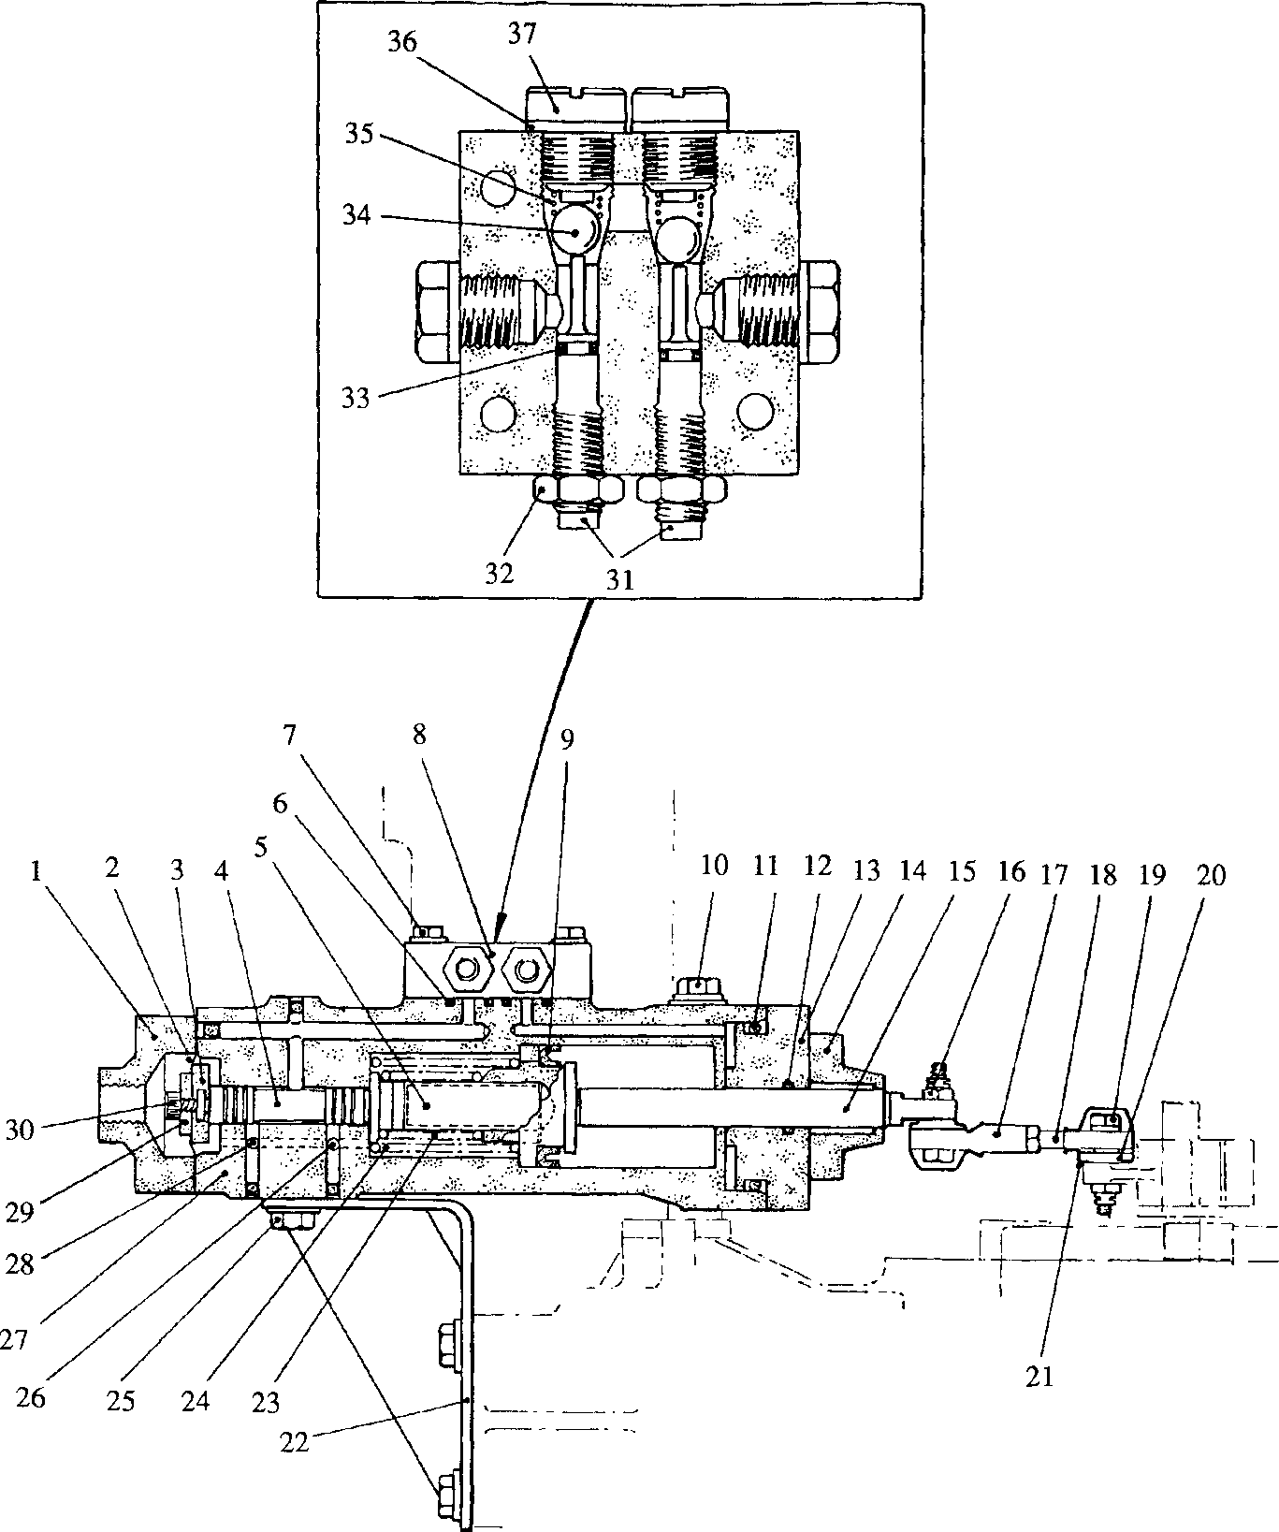

--

SPD00357

Fig KE.l Diversion valve actuator

Key To Numbers

1. 'O' ring, diversion valve to by-pass
2. 'O' ring, diversion valve to branch pipe
3. Capscrew, clamping lever to spindle
4. 'O’ ring, diversion valve to turbocharger outlet pipe
5. Body, diversion valve
6. Diversion valve
7. Pin, diversion valve to spindle
8. Cover, lower
9. Setscrews, covers to body
10. Washer schnorr
11. Cover, upper
12. Key, lever to spindle
13. Operating lever
14. Spindle
15. 'O' ring, spindle to upper cover
16. 'O' rings, covers to body

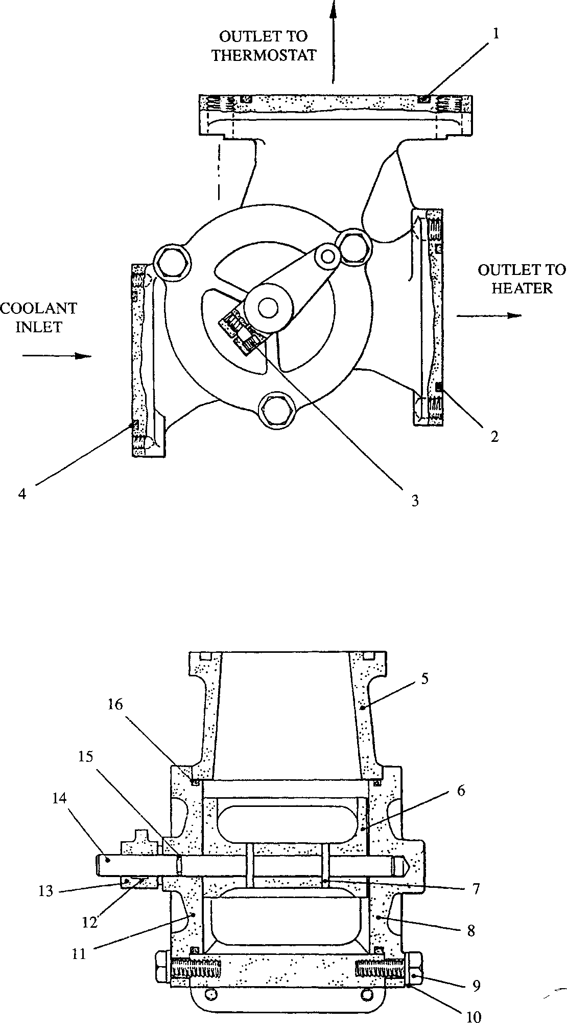

**SPD00356**

**Fig KE.2 Diversion valve**